**A PROJECT REPORT ON**

**“MovieMate”**

**”**

**Prepared by**

Parmar Abhishrut (RU230448)

**Under the guidance of**

Mr.SP Acharya

**Submitted in**

Partial fulfillment of the Requirements for the Degree of B.TECH

B.TECH SEMESTER-IV

**Submitted at**



**APRIL - 2025**

**DEPARTMENT OF COMPUTER SCIENCE AND ENGINEERING**

**RAI SCHOOL OF ENGINEERING**

**RAI UNIVERSITY, SARODA, DHOLKA - 382260**

**DIST: AHMEDABAD, GUJARAT**

**RAISCHOOLOFENGINEERING**



**CERTIFICATE**

This is to certify that Mr. Parmar Abhishrut of B.TECH Semester IV has completed her project work titled “**MOvieMate**” satisfactorily in partial fulfillment of the requirement of B.TECH degree, Rai University, Saroda, Ahmedabad in the year 2025..

### Internal Guide Head of Department

Mr.SP Acharya Ms. Poonam Chakravarty

Assistant Professor

Department of CSE

**CSE Department**

**Date: 11/04/2025 Date:11/04/2025**

# ACKNOWLEDGEMENT

We fall short of words to pen down anything for the co-operation and encouragement extended by

parents through the completion of this project.

I am grateful to my University, RAI SCHOOL OF ENGINEERING, RAI UNIVERSITY

for giving me this wonderful opportunity to undertake this training.

I convey my sincere thanks to Dr. Sailesh Iyer (DEAN, Rai School of Engineering, Rai University),

Ms. Poonam Chakravarty (HOD CSE, Rai School of Engineering, Rai University),

and (Mr.SP Acharya) (My Internal Project Guide) for providing me his time, constructive criticism

and valuable guidance. The guidance and support received from all the other faculty members

who contributed to this project, was vital for the success of the project. Besides this, I would like to

thank all those people who helped me in one or the other way

We would like to express our very great application to our Internal Guide (Mr.SP Acharya) for her valuable and constructive suggestions during the planning and development of this project. His willingness to give his time so generously has been very much appreciated. Advice given by other academic lectures has been a great help in building the software solution.

We are very thankful to everyone who supported us for this assignment and gives their guidance to complete our theses work effectively and moreover on time

# CANDIDATE’SDECLARATION

I hereby declare that, the project report titled “MovieMate.” submitted towards the partial completion of Project in Semester IV, of the B.TECH in RSE, Rai University, Ahmedabad is an authentic record of my work carried out..

I further declare that the work reported in this project has not been submitted and will not be submitted, either in part or in full for the award of any other degree in this institute or any other institute.

Candidate’s Signature

Candidate’s Name : **Parmar Abhishrut Mehulkumar**

Branch : **Btech (CSE)**

Enrollment No :**RU230448**

This is to certify that the above statement made by the candidate is correct to the best of my knowledge.

Signature of Guide

Guide (SP Acharya)

**TABLE OF CONTENTS**

**Title Page No.**

**CERTIFICATE II**

**ACKNOWLEDGEMENT III**

**CANDIDATE’S DECLARATION IV**

**TABLE OF CONTENTS V**

**ABSTRACT 6**

**CHAPTER 1:**

**INTRODUCTION**

1.1 Project Profile

1.2 About Project

**CHAPTER 2:**

**ENVIRONMENT DESCRIPTION**

2.1 System Hardware & Software Requirements

2.2 Technology Use

2.2.1 Features of Technology

2.2.2 Features of Technology up to Number of Technology has been used

**CHAPTER 3:**

**EXISTING SYSTEM**

3.1 Working of Existing System Component

3.2 Drawbacks of Existing System

**CHAPTER 4:**

**SYSTEM PLANNING**

4.1 Feasibility Study

4.2 Requirement Analysis And Data Gathering

4.2.1 Requirement Gathering

4.2.2 Requirement Analysis

**CHAPTER 5:**

**PROPOSED SYSTEM**

5.1 Scope

5.1.1 Scope Of System

5.2 Objectives

5.3 Constraints

5.4 Admin

5.5 User

5.6 Expected Advantages

**CHAPTER 6:**

**DETAIL PLANNING (If applicable put all the diagram which are related to project)**

6.1 Data Flow Diagram

6.2 E-R Diagram

6.3 Use-case Diagram

6.4 Activity Diagram

6.5 Data Dictionary

**CHAPTER 7:**

**PROJECT SCREENSHOTS**

**7.1 Website Screenshots**

**REFERENCE**

**Campus X -YouTube**

**ABSTRACT**

**MovieMate** is a personalized movie recommendation web application designed to enhance user entertainment experiences through intelligent content suggestions. By leveraging a machine learning model integrated with a user-friendly React-based frontend and a Flask backend, MovieMate delivers curated movie recommendations based on user inputs. The application allows users to enter the name of a movie they like and receive a list of similar movies that match their taste.

The primary objective of MovieMate is to reduce the time and effort users spend deciding what to watch next. It features a dynamic interface that includes a modern hero section, trending movie displays, and an interactive recommendation engine. The machine learning component is trained on a movie dataset that captures various similarities and viewer preferences, ensuring accurate and engaging suggestions.

MovieMate's architecture follows a full-stack design:

* **Frontend:** Built using React.js and styled with advanced CSS and Framer Motion for animations.
* **Backend:** Developed with Flask, which handles API requests and communicates with the ML model.
* **ML Module:** Processes user input and computes relevant movie recommendations.

This seamless integration of technologies makes MovieMate a powerful and intuitive tool for movie enthusiasts seeking personalized entertainment options.

**INTRODUCTION**

* 1. **PROJECT PROFILE**

|  |  |
| --- | --- |
| Project Name: | MovieMate |
| Technology: | React.js, Node.js, MongoDB, Express.js, Python, NLTK |
| Front-End: | React.js |
| Back- End: | Node.js, Express.js ,MongoDB |
| Project Guide: | SP Acharya |
| Submitted to: | Rai University, Ahmedabad |
| Developed by: | Parmar Abhishrut |

**1.2 ABOUT PROJECT**

**MovieMate** is a personalized movie recommendation web app built with React.js, Flask, and Machine Learning.  
Users can input a movie name and receive intelligent suggestions for similar titles.  
The frontend features a modern, animated UI using Framer Motion and advanced CSS.  
The backend handles API calls and connects to a trained ML model for accurate recommendations.  
MovieMate aims to simplify content discovery and enhance user entertainment experiences.

**CHAPTER 2: ENVIRONMENT DESCRIPTION**

**2.1 System Hardware & Software Requirements**

**Hardware Requirements:**

* Processor: Intel i5 or higher
* RAM: Minimum 4 GB
* Disk Space: Minimum 2 GB

**Software Requirements:**

* OS: Windows/Linux/Mac
* Backend: Node.js, Flask (Python)
* Frontend: React.JS
* Database: MongoDB
* Version Control: Git & GitHub

**2.2 Technology Use**

**2.2.1 Features of Technology**

* **React.js for a dynamic, component-based frontend with routing and animations**
* **Flask for lightweight, scalable backend API handlingExpress.js** for API handling
* **Python (Scikit-learn) for implementing machine learning-based movie recommendations**
* **Git & GitHub** for version control and collaboration

**2.2.2 Summary of Technologies Used**

1. React.js
2. Node.js,
3. Express.js
4. MongoDB
5. Flask (Python)
6. Scikit-learn
7. Pandas
8. Numpy
9. Git & GitHub

**CHAPTER 3: EXISTING SYSTEM**

**3.1 Working of Existing System Components**

Currently, movie recommendation platforms are either generalized or rely on manual user input without personalized intelligence. These systems may:

* Display trending movies without personalization.
* Rely on manual search and genre filtering.
* Lack intelligent recommendation based on user input.
* Offer limited interactivity and engagement.
* Do not integrate ML-based learning from user preferences.

**3.2 Drawbacks of Existing System**

• Generic and non-personalized recommendations.

• Manual and time-consuming movie search.

• No learning from user preferences.

• Basic, non-interactive user experience.

• Scattered data across multiple platforms.

**CHAPTER 4: SYSTEM PLANNING**

**4.1 Feasibility Study**

The project was found feasible in terms of cost, time, and technical implementation. The tech stack is open-source and easy to scale, making it suitable for educational and practical usage**.**

**4.2 Requirement Analysis and Data Gathering**

**4.2.1 Requirement Gathering**

**• User interviews on movie watching habits  
• Online surveys about favourite genres and platforms  
• Secondary research on recommendation systems  
• Study of existing movie apps like Netflix and IMDb**

**4.2.2 Requirement Analysis**

**• Need for a clean and engaging UI  
• Personalized movie recommendation feature  
• Integration with a movie database  
• Quick and responsive search functionality**

**CHAPTER 5: PROPOSED SYSTEM**

**5.1 Scope**

**5.1.1 Scope of System**

*MovieMate* will be a web-based platform accessible to users seeking personalized movie recommendations. The system will feature a user-friendly interface, real-time suggestions using ML models, trending movie displays, and a responsive design. Users can enter their favorite movie, and the platform will provide intelligent recommendations based on similarity. It aims to enhance the movie discovery experience by combining interactivity with smart backend processing.

**5.2 Objectives**

**• Enhance the movie discovery experience through intelligent recommendations  
• Provide an engaging and user-friendly interface  
• Utilize machine learning for personalized suggestions  
• Display trending and popular movies in real-time  
• Offer a seamless movie search and recommendation process**

**5.3 Constraints**

* Internet access is required for fetching recommendations
* Recommendation accuracy depends on dataset quality
* Cold-start problem for new or obscure movies
* Backend server must be running for full functionality
* Limited personalization without user login or history

**5.4 User**

**Users can:**

• Search and input their favorite movies  
• Get AI-based movie recommendations  
• View trending and recommended movies  
• Navigate a modern, responsive UI  
• Learn about similar movies they may enjoy

**5.6 Expected Advantages**

* Personalized movie discovery experience
* Improved user engagement through AI recommendations
* Saves users time searching for what to watch
* Encourages exploration of diverse movie genres
* Sleek and interactive user interface enhances satisfaction

**CHAPTER 6: DETAIL PLANNING**

**6.1 Data Flow Diagram**

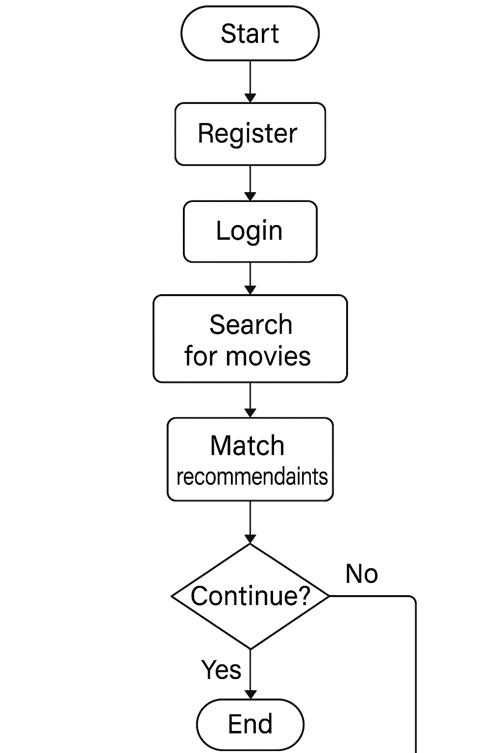

**6.2 E-R Diagram** 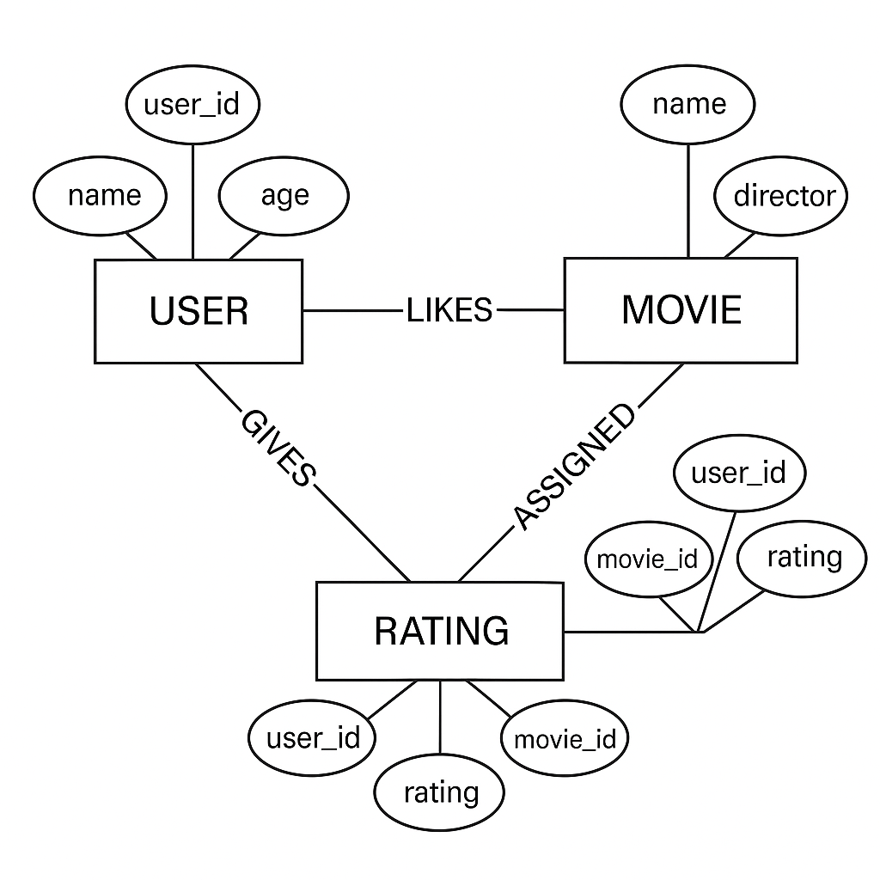

6.3 Use-case Diagram 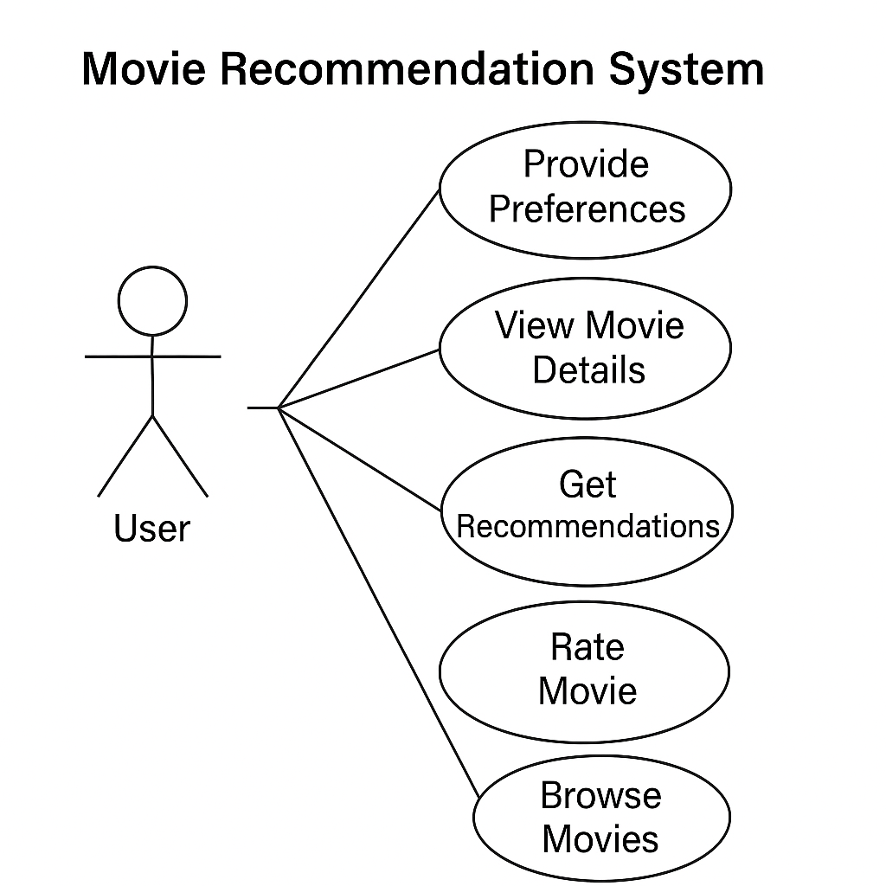

**6.4 Activity Diagram**

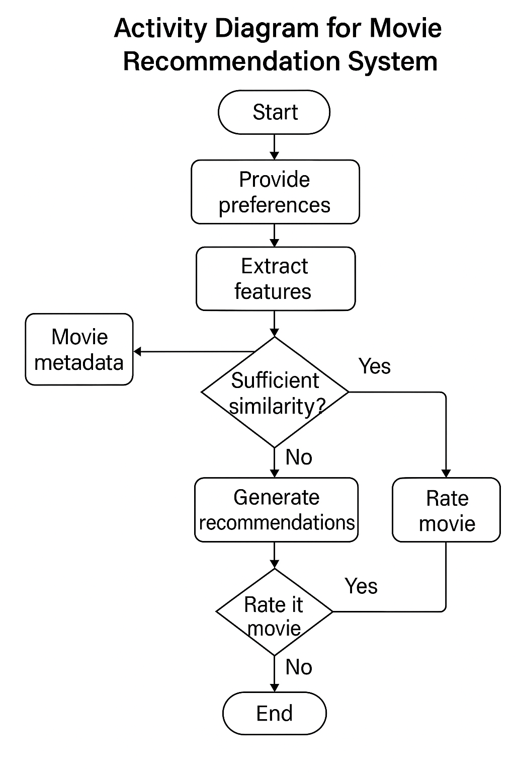

+

**7.1 website screenshots**

7.1.1 Home Page

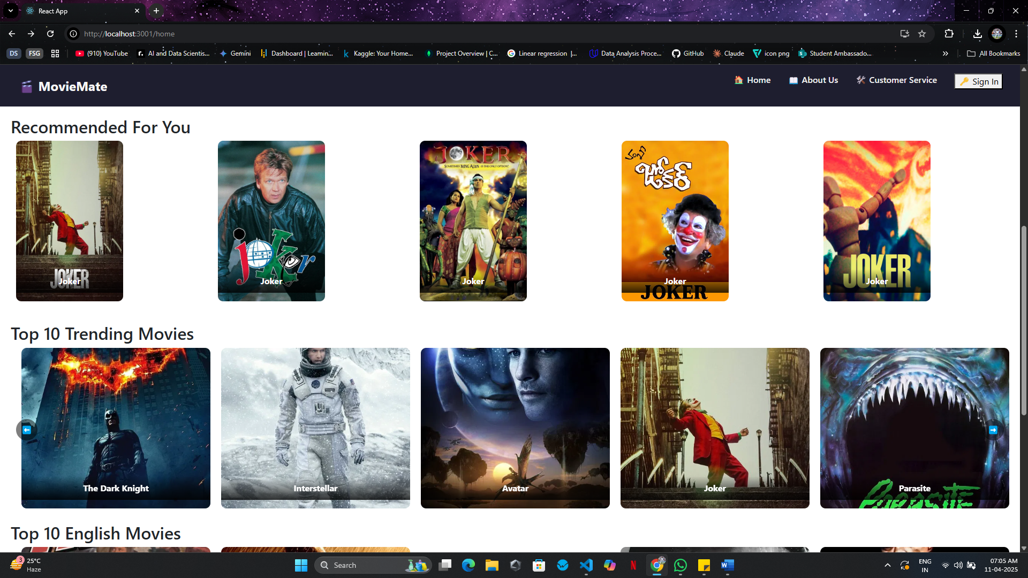

7.1.2 Home Page

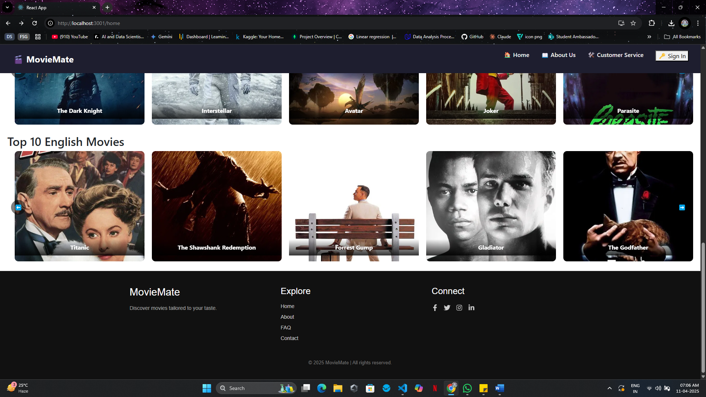

**7.1.3 About Page**

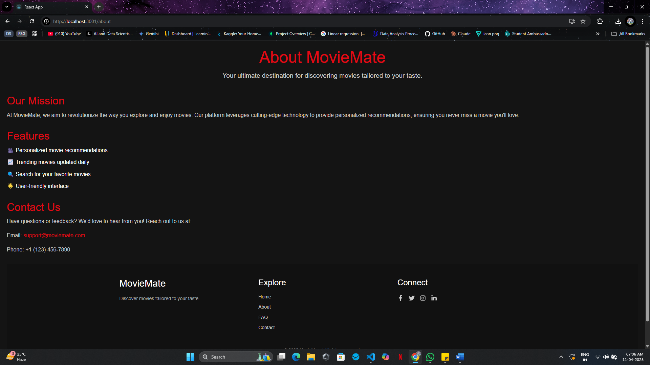

7.1.4 Login Page

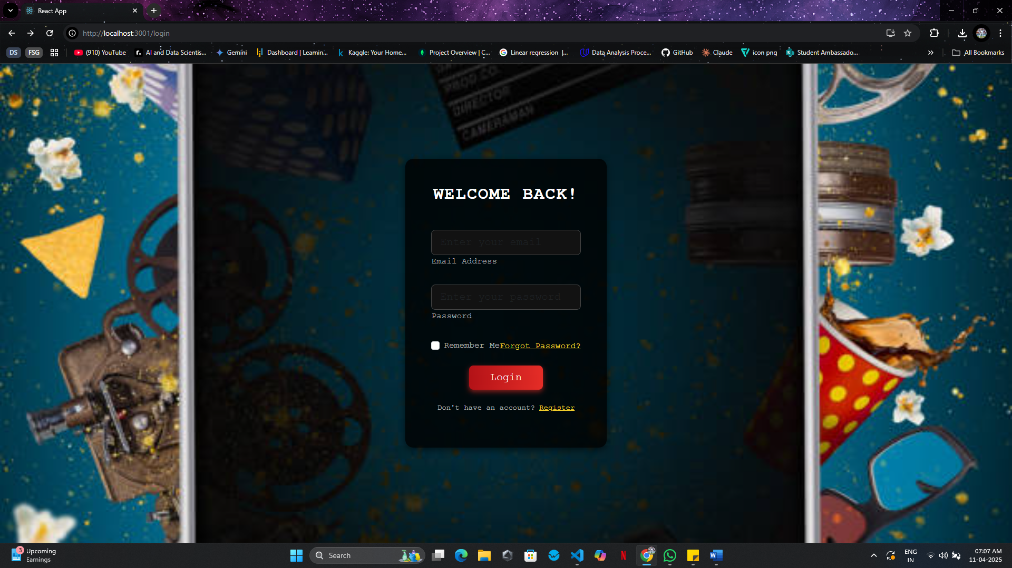

**7.1.5 SignIn Page**

